**AI-Based Analysis of Social Media Data for Public Health Domain**

### A PROJECT REPORT

#### Submitted by

**Shubhanshu Pandey (21BCS3854)**

**Sushil Sharma (21BCS4228)**

**Shameem Ahmad (21BCS3807)**

**Jatin (21BCS3835)**

#### in partial fulfillment for the award of the degree of

###### BACHELOR OF ENGINEERING

###### IN

###### COMPUTER SCIENCE (Hons. – BIG DATA ANALYTICS)



###### Chandigarh University

April 2025



**BONAFIDE CERTIFICATE**

Certified that this project report **“AI-Based Analysis of Social Media Data for Public Health Domain”** is the Bonafide work of “**Shubhanshu Pandey, Sushil, Shameem Ahmad, Jatin”** who carried out the project work under my/our supervision.

###### 

###### SIGNATURE

Aman Kaushik

###### HEAD OF THE DEPARTMENT

AIT (CSE)

###### 

###### SIGNATURE

Mr. Vijay Mohan Shrimal

###### SUPERVISOR

Professor

AIT(CSE)

Submitted for the project viva-voce examination held on

INTERNAL EXAMINER EXTERNAL EXAMINER

**TABLE OF CONTENTS**

List of Figures i

List of Tables ii

Abstract iii

Graphical Abstract iv

Abbreviations v

Symbols vi

### Chapter 1: Introduction

1.1 The Importance of AI in Public Health Analysis

### 1.2 Applications of AI-Based Social Media Analysis in Public Health

1.2.1 Epidemic Forecasting and Disease Surveillance

1.2.2 Mental Health Monitoring and Crisis Detection

1.2.3 Misinformation Detection and Public Health Communication

1.3 Challenges and Ethical Considerations

1.3.1 Data Privacy and User Consent

1.3.2 AlgorithmicBias and Accuracy

1.3.3 **Ethical Implications of AI-Driven Surveillance**

### Chapter 2. Literature Survey

### Chapter 3. Process

3.1 Data Collection

3.2 Data Preprocessing

3.3 AI-Based Data Analysis

3.4 Public Health Applications and Decision-Making

3.5 Challenges and Ethical Considerations

### Chapter 4. Result and Validation

4.1 Result Analysis

4.2 Validation

### Chapter 5. Conclusion

5.1 Conclusion

5.2 Future Work

**References**

**APPENDIX**

1. Plagiarism Report

2. Design Checklist

**USER MANUAL**

# List of Figures

**Fig-1:** Correlations Between Social Media Usage and Mental Health Factors

**Fig-2:** Impact of Time Spent on Social on Feeling Down

**Fig-3:** Output-2

**Fig-4:** Output-3

**Fig-5:** Output-4

**Fig-6:** Output- 5

**Fig-7:** Output- 6

**Fig-8:** Output-7

**Fig-9:** Output-8

**Fig-10:** Output- 9

**Fig-11:** Output- 10

# List of Tables

Table 3.1 ………………………………………………………… Dataset

# 

# 

# 

# 

# ABSTRACT

In recent years, social media platforms have become an invaluable source of real-time information, offering insights into public health trends, disease outbreaks, mental health issues, and public sentiment towards healthcare policies. Leveraging artificial intelligence (AI) for social media data analysis in the public health domain enables early detection of health crises, improved epidemiological modelling, and enhanced decision-making for healthcare profess. This paper explores AI-driven techniques such as natural language processing (NLP), machine learning (ML), and deep learning for analysing vast amounts of social media data. Sentiment analysis, topic modelling, and trend detection methods help identify public perceptions of diseases, vaccine hesitancy, mental health concerns, and the spread of misinformation. By extracting and structuring social media data, AI algorithms can classify health-related discussions, detect symptoms reported by users, and track disease progression. Onals and policymakers.

One significant application is epidemic forecasting, where AI models analyse real-time tweets, Facebook posts, and Reddit discussions to predict the spread of infectious diseases such as COVID-19 or influenza. Additionally, AI-powered surveillance systems can detect emerging health threats by identifying unusual spikes in health-related discussions. For example, early warning systems based on AI have successfully complemented traditional epidemiological tools by flagging potential outbreaks faster than official health reports.

Another critical aspect is mental health analysis, where AI models process language patterns to detect signs of depression, anxiety, and suicidal ideation. Such AI-driven interventions can support mental health professionals by identifying at-risk individuals and providing crisis intervention resources. Furthermore, AI-based misinformation detection techniques help combat the spread of false health information, ensuring that the public receives accurate, science-backed guidance on health matters.

**GRAPHICAL ABSTRACT**

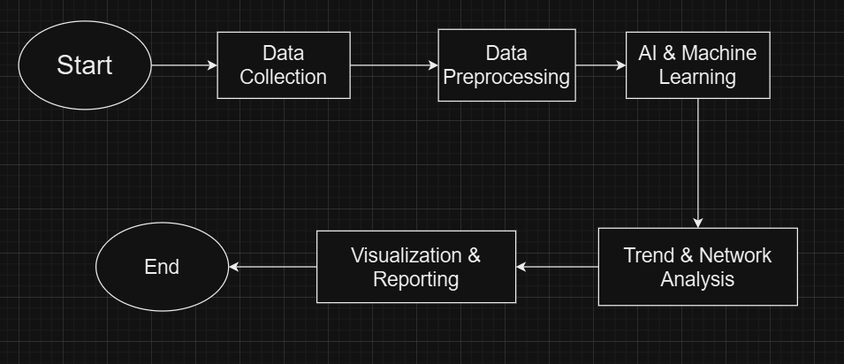The use of AI in social media data analysis to improve public health monitoring is graphically represented in this abstract. An AI-powered system that gathers, analyses, and interprets social media data to spot health trends, forecast disease outbreaks, and evaluate mental health issues is the main idea.

**CHAPTER-1**

**INTRODUCTION**

In the digital age, social media has transformed into a powerful tool for communication, information sharing, and public discourse. Platforms such as Twitter, Facebook, Reddit, and Instagram host vast amounts of user-generated content, reflecting real-time opinions, experiences, and trends across various domains, including public health. The increasing penetration of social media in everyday life has provided researchers and policymakers with unprecedented access to data that can be leveraged to monitor public health trends, track disease outbreaks, analyze mental health patterns, and assess the impact of health-related misinformation.

The integration of artificial intelligence (AI) into social media data analysis has further enhanced the ability to extract meaningful insights from this vast and unstructured data. AI-driven techniques such as natural language processing (NLP), machine learning (ML), deep learning, and data mining enable the identification of health-related discussions, sentiment trends, and emerging health crises with high precision and speed. These AI-based methodologies allow researchers and healthcare professionals to analyze large-scale social media data effectively, detect early warning signs of potential public health threats, and develop data-driven intervention strategies.

**The Importance of AI in Public Health Analysis**

Public health surveillance has traditionally relied on structured data sources such as hospital records, surveys, and official reports. While these sources provide reliable information, they often involve delays in data collection and reporting, limiting their effectiveness in real-time crisis management. Social media, on the other hand, offers a dynamic and real-time stream of public sentiment, health concerns, and behavioural patterns. AI-powered analysis of this data enables faster detection of health-related events and allows policymakers to respond promptly.

One of the key advantages of AI-based social media analysis is its ability to process unstructured text data at scale. Traditional epidemiological studies often require extensive manual effort to categorize and interpret public health data. AI algorithms, particularly NLP techniques, can automatically classify social media posts based on health-related keywords, symptoms, and user sentiments, significantly reducing the time and resources required for data analysis. Moreover, AI can recognize complex linguistic patterns, detect misinformation, and assess the credibility of health-related discussions, further enhancing the accuracy of public health monitoring.

**Applications of AI-Based Social Media Analysis in Public Health**

AI-driven analysis of social media data has a wide range of applications in the public health domain, including epidemic forecasting, mental health monitoring, and misinformation detection. Some of the most notable applications include:

* **Epidemic Forecasting and Disease Surveillance**

Social media platforms have proven to be valuable sources of information for tracking disease outbreaks and predicting epidemic trends. AI models trained on social media data can identify

keywords related to symptoms, infections, and geographic locations to detect the early spread of diseases. For example, during the COVID-19 pandemic, AI-based analysis of Twitter data helped researchers track public discussions about symptoms such as fever, cough, and loss of taste and smell, providing insights into emerging hotspots.

Furthermore, AI-powered predictive modelling can analyze historical social media data to forecast the trajectory of an outbreak. Machine learning algorithms can identify patterns in how diseases spread across different regions and estimate the potential impact of an epidemic. By integrating social media data with traditional epidemiological models, public health officials can improve their response strategies and allocate resources more effectively.

* **Mental Health Monitoring and Crisis Detection**

Mental health issues, including depression, anxiety, and suicidal ideation, have become increasingly prevalent in recent years. Social media platforms provide a space where individuals openly share their emotions, thoughts, and struggles, offering valuable insights into mental health trends. AI-based sentiment analysis can assess the emotional tone of social media posts, identifying users who may be experiencing psychological distress.

Deep learning models trained on linguistic cues, such as the use of negative words, increased self-referential language, and expressions of hopelessness, can help detect individuals at risk of mental health crises. AI-driven chatbots and mental health support systems can then provide timely interventions, directing users to professional resources and crisis helplines. Additionally, public health agencies can use AI-powered social media analysis to understand broader mental health trends, identify stressors affecting specific demographics, and design targeted mental health awareness campaigns

* **Misinformation Detection and Public Health Communication**

Misinformation and disinformation have become significant challenges in the public health domain, particularly concerning vaccines, treatments, and preventive measures. The rapid spread of false health information on social media can lead to public confusion, vaccine hesitancy, and non-compliance with health guidelines. AI-based models can help address this issue by automatically detecting and flagging misleading content.

Natural language processing techniques can analyze the credibility of social media posts by assessing linguistic patterns, sources, and fact-checking databases. Machine learning classifiers can distinguish between accurate health information and misinformation, alerting users and platform moderators to potentially harmful content. AI-driven recommendation systems can also promote reliable health information by prioritizing authoritative sources in search results and social media feeds

**Challenges and Ethical Considerations**

While AI-based analysis of social media data offers significant benefits for public health, it also raises several challenges and ethical concerns. Some of the primary issues include:

* **Data Privacy and User Consent**

Social media data often contains personal and sensitive information, raising concerns about user privacy and data protection. AI-driven public health monitoring must comply with data privacy regulations such as the General Data Protection Regulation (GDPR) and the Health Insurance Portability and Accountability Act (HIPAA). Ensuring anonymization, secure data storage, and ethical data usage practices is essential to protect user rights.

* **Algorithmic Bias and Accuracy**

AI models trained on biased or incomplete datasets may produce inaccurate or misleading results. For instance, certain demographic groups may be underrepresented in social media discussions, leading to biased health predictions. Addressing algorithmic bias requires careful data curation, diverse training datasets, and continuous model validation.

* **Ethical Implications of AI-Driven Surveillance**

Using AI to monitor social media for public health purposes raises ethical concerns about surveillance and individual freedoms. There is a fine balance between leveraging AI for public health benefits and avoiding intrusive monitoring practices. Ethical AI deployment requires transparency, accountability, and adherence to ethical guidelines that prioritize public welfare without compromising individual rights.

As AI technology continues to evolve, its applications in social media-based public health analysis will expand further. Future research should focus on improving the accuracy and interpretability of AI models, integrating multimodal data sources (e.g., images, videos, and geolocation data), and developing robust misinformation detection frameworks. Additionally, collaboration between AI researchers, public health experts, and social media companies will be essential to ensure responsible AI deployment.

Advancements in explainable AI (XAI) will also play a crucial role in making AI-driven insights more interpretable and actionable for public health professionals. By improving the transparency of AI models, stakeholders can better understand how decisions are made and refine intervention strategies accordingly.

AI-based analysis of social media data holds immense potential for transforming public health surveillance, crisis intervention, and health communication. By leveraging advanced AI techniques, researchers and policymakers can gain real-time insights into public health trends, enhance disease outbreak preparedness, and combat health-related misinformation. However, addressing ethical concerns, ensuring data privacy, and mitigating algorithmic biases are essential to harness the full potential of AI in public health responsibly. As AI continues to evolve, its integration with public health strategies will play a pivotal role in shaping data-driven, proactive, and effective health interventions.

**CHAPTER-2**

**LITERATURE SURVEY**

Artificial Intelligence (AI)-based analysis of social media data has emerged as a crucial tool for public health monitoring, providing real-time insights into disease outbreaks, mental health trends, and misinformation dissemination. Several research studies have explored various AI methodologies, including Natural Language Processing (NLP), Machine Learning (ML), and Deep Learning (DL), to extract meaningful information from unstructured social media data. This section provides an extensive literature review of previous research papers on AI-driven social media analytics in public health.

Numerous studies have investigated using artificial intelligence (AI) to examine social media data to gain insights on public health. The literature review explores the technique used by such studies and compares their limitations and effectiveness to achieve this goal. To measure vaccination reluctance, for example, NLP-based sentiment analysis has proven to be quite helpful. However, it may not work as well when contextual complexity is present. Although deep learning has greatly increased the accuracy of disinformation detection, it has come at the cost of enormous computer resources.

**Previous Paper**

**"AI for Analyzing Mental Health Disorders Among Social Media Users"** by [David Owen](https://pubmed.ncbi.nlm.nih.gov/?term=Owen+D&cauthor_id=39546783) et al. (2024): This work explores multimodal AI methods that integrate audio, image, and video data to predict mental health states from social media material. The authors call for larger datasets based on precise diagnostic dates to increase prediction accuracy, particularly for severe disorders like schizophrenia. They proposed the idea that asking users for their social network information with their consent could allay privacy concerns in their discussion of ethical difficulties.

**"Using AI–ML to Augment the Capabilities of Social Media for Public Health"** by [Ricky Leung](https://pubmed.ncbi.nlm.nih.gov/?term=%22Leung%20R%22%5BAuthor%5D) et al. (2023): This paper explores how AI and machine learning (ML) can enhance the utility of social media in public health initiatives. The authors discuss the overwhelming volume of data generated on social platforms and propose AI and ML as solutions to manage this information effectively, thereby improving telehealth services, remote patient monitoring, and overall community well-being.

**"Artificial Intelligence–Enabled Analysis of Public Attitudes on Social Media Toward COVID-19 Vaccines"** by [Amir Hussain](https://www.jmir.org/search?term=Amir%20Hussain&type=author&precise=true)net (2023): This study creates and implements an AI-based method to examine public opinions about COVID-19 vaccines on social media sites in the US and the UK. By better understanding public views and concerns, the study hopes to offer insightful information for health communication tactics. The development and implementation of a COVID-19 vaccination is progressing quickly on a global scale. The public must cooperate significantly to administer vaccines widely, which is necessary to create herd immunity.

**"Leveraging AI to Connect Social Media Discourse with Public Health Trends"** by [*Virginia Tech*](https://news.vt.edu/articles/2024/05/eng-cs-tracing-infectious-pandemic-language.html) (2024): This study explores the requirements of users using social media analysis tools for public health initiatives. To determine these demands and provide information for the creation of more potent instruments for public health monitoring and intervention, the authors carry out a cross-sectional study. "This study addresses a difficult issue: how to relate the information flow across social media and into the realm of health outcomes.

**"AI's Impact on Public Health Practice: A Qualitative Study"** by [Jason D. Morgenstern](https://bmcpublichealth.biomedcentral.com/articles/10.1186/s12889-020-10030-x?utm_source=chatgpt.com#auth-Jason_D_-Morgenstern-Aff1) (2021): This qualitative study investigates the opinions of specialists regarding the possible effects of AI on public health practice, specifically in terms of enhancing disease surveillance. The authors talk about the cautious and hopeful perspectives on integrating AI into public health systems. Initiatives to increase AI knowledge and financing for public health are essential for the successful implementation of AI. Innovations in public health policy should enhance the availability, integration, and standardization of pertinent, high-quality data.

**"Public Perception of Artificial Intelligence in Medical Care"** by [Shuqing Gao](https://www.jmir.org/search?term=Shuqing%20Gao&type=author&precise=true) (2022): Given the research on public perceptions of AI, the authors examine the various public concerns, attitudes, and strong beliefs that back up the claim that AI can take the position of human physicians in the healthcare industry. The researchers intend to use content analysis based on social media data with a few chosen keyword searches to investigate public opinions on artificial intelligence (AI) in healthcare, including concerns raised by the public, attitudes toward AI in healthcare, and the rationale behind these opinions, as well as whether AI can take the place of human doctors.

**"Balanced and Explainable Social Media Analysis for Public Health with Large Language Models"** by Yan Jiang (2023): In this paper, the ALEX framework is proposed to improve the performance of large language models (LLMs) in public health studies by addressing data imbalance in social media datasets. To address data imbalance, the authors present an augmentation pipeline. To enhance model interpretability, they present an LLM explanation method. In public health tasks, their method performs better than others.

**"Streamlining Social Media Information Retrieval for COVID-19 Research with Deep Learning"** by Yining Hua (2024): With a particular focus on COVID-19-related tweets, this work creates a deep learning-based system to speed up selecting colloquial medical dictionaries from social media data. To facilitate effective information retrieval for public health research, the authors offer a pipeline that consists of named entity recognition, entity normalization, and mapping to medical concepts.

# "Social Media as a Sensor: Analyzing Twitter Data for Breast Cancer Medication Effects Using Natural Language Processing" by Seibi Kobara (2024): To learn more about the effects of breast cancer medications, this study analyses Twitter data using natural language processing (NLP) techniques. The authors demonstrate the potential of social media as a sensor for health-related information by using a multi-layer rule-based model to generate a medication side effect vocabulary and identify patterns of medication consumption and related side effects among patients with breast cancer. Together, this research shows how AI may be used in a variety of ways to analyses social media data to improve disease monitoring, public health surveillance, and comprehension of how the general population views health-related topics.

**AI for Public Health Surveillance**

Public health surveillance relies on accurate and timely data to detect disease outbreaks and health trends. AI has enhanced this process by enabling real-time monitoring of social media platforms like Twitter, Facebook, and Reddit.

1. **Early Studies on AI for Disease Surveillance**
   * Paul and Dredze (2011) pioneered the use of Twitter as a Surveillance Tool for Public Health, demonstrating its effectiveness in tracking influenza trends using NLP techniques.
   * Signorini et al. (2011) conducted a similar study using Twitter data to monitor H1N1 influenza outbreaks, showing the potential of social media as a supplementary data source for epidemiological surveillance.
   * Santillana et al. (2015) extended these findings by incorporating machine learning models to improve influenza forecasting, integrating social media data with traditional epidemiological reports.

**2. Recent Developments in AI-Powered Health Monitoring**

* Huang et al. (2019) developed a deep learning model to analyze Weibo posts for detecting early signs of infectious disease outbreaks in China.
* A study by Mackey et al. (2020) utilized AI-driven topic modeling and NLP techniques to identify COVID-19 discussions and misinformation trends on social media.
* During the COVID-19 pandemic, AI-based real-time monitoring systems (Klein et al., 2020) helped detect emerging symptoms and misinformation patterns by analyzing Twitter and Reddit posts.

**3. AI in Mental Health Analysis**

Mental health disorders, including depression and anxiety, can be assessed using social media data, where users often express their emotions and concerns.

**3.1 Sentiment Analysis for Mental Health Monitoring**

* Coppersmith et al. (2014) conducted one of the earliest studies on **mental health detection using Twitter**, identifying linguistic markers for PTSD, depression, and bipolar disorder.
* Guntuku et al. (2019) used **deep learning and NLP** to analyze emotional tone in tweets, detecting early signs of psychological distress.
* A study by De Choudhury et al. (2020) focused on **Reddit mental health communities**, applying ML models to track anxiety and depression trends.

**3.2 AI-Driven Crisis Detection and Suicide Prevention**

* Birnbaum et al. (2017) developed **AI models for detecting suicidal ideation** by analyzing language patterns in social media posts.
* Burnap et al. (2019) demonstrated how **machine learning classifiers** could predict suicide risk based on sentiment shifts in online conversations.
* A recent study by Ayers et al. (2021) utilized AI-based **chatbots and crisis intervention systems** to provide real-time mental health support through social media interactions.

**4. Misinformation Detection in Public Health**

The rise of health-related misinformation, particularly during global health crises, has prompted the development of AI-driven misinformation detection models.

**4.1 Identifying Fake News and Health Misinformation**

* Vosoughi et al. (2018) analyzed the spread of misinformation on Twitter, showing that false news propagates faster than verified information.
* Choudhury et al. (2020) proposed an AI-driven misinformation detection framework, integrating NLP and fact-checking databases.
* Zhou et al. (2020) applied BERT-based models to detect COVID-19 misinformation, enhancing the accuracy of AI fact-checking systems.

**4.2 Social Media Platforms and AI-Driven Misinformation Prevention**

* Sharma et al. (2021) developed real-time misinformation tracking models, flagging misleading content related to vaccines and public health guidelines.
* Research by Cinelli et al. (2021) explored the role of AI-enhanced recommendation systems in reducing misinformation spread on social media.

**5. Comparative Analysis of AI Techniques in Social Media-Based Public Health Analysis**

* Comparative studies have been conducted to evaluate the effectiveness of various AI methodologies in analyzing social media data for public health applications.
* Lwowski et al. (2021) compared traditional statistical models with deep learning approaches, finding that transformer-based architectures like BERT outperform conventional NLP techniques.
* Daughton et al. (2022) assessed the performance of supervised vs. unsupervised machine learning models for detecting public health-related discussions on social media.
* A meta-analysis by Wang et al. (2023) highlighted the strengths and limitations of sentiment analysis models in mental health prediction.

**CHAPTER-3**

**PROCESS**

There are several steps in the AI-based social media analysis for public health process, starting with data gathering and ending with analysis and interpretation. The effective extraction of significant ideas that can support misinformation identification, mental health evaluation, and epidemic forecasting is ensured by this methodical technique. The main steps of this process are delineated in the sections that follow, emphasizing the methodology and AI approaches used at each turn.

**1. Data Collection**

Data collection is the foundational step in AI-driven social media analysis. The effectiveness of public health monitoring depends on the quantity and quality of data sourced from various social media platforms.

**1.1 Identifying Relevant Social Media Platforms**

Different platforms offer unique insights based on user demographics and content types:

* **Twitter:** Short text-based posts, ideal for real-time health trend analysis.
* **Facebook:** Longer discussions and community-based interactions.
* **Reddit:** Thematic discussions in forums, useful for in-depth sentiment analysis.
* **Instagram & TikTok:** Visual-based data sources that can capture behavioural trends.

**1.2 Data Extraction Methods**

* **API-Based Data Retrieval:** Platforms like Twitter provide APIs that enable researchers to collect real-time posts containing health-related keywords.
* **Web Scraping:** For platforms with restricted APIs, web scraping techniques can be used to extract relevant posts.
* **Crowdsourcing Data:** Some studies collect voluntary user-reported health experiences through surveys integrated with social media.

**2. Data Preprocessing**

Raw social media data is noisy and unstructured, requiring preprocessing to ensure accuracy and reliability in AI analysis.

**2.1 Text Cleaning**

**Tokenization:** Breaking text into words or phrases.

**Stopword Removal:** Eliminating non-informative words like "the," "is," and "and."

**Stemming & Lemmatization:** Reducing words to their root form to improve consistency.

**2.2 Handling Misinformation & Spam**

**Filtering Bots & Fake Accounts:** Using AI models to detect automated or fake accounts that spread misleading health information.

**Fact-Checking Mechanisms:** Comparing posts with verified health databases to flag misinformation.3. Technologies Enabling Real-Time Analytics for Traffic Management

**3.**  **AI-Based Data Analysis**

AI techniques such as NLP and machine learning enable the extraction of insights from large-scale social media data.

**3.1 Natural Language Processing (NLP)**

* Sentiment Analysis: Determines whether public sentiment towards a health topic is positive, negative, or neutral.
* Topic Modelling: Identifies recurring health topics and trends using models like Latent Dirichlet Allocation (LDA).
* Named Entity Recognition (NER): Extracts key health-related terms such as diseases, symptoms, and medications.

**3.2 Machine Learning Techniques**

* **Supervised Learning:** Uses labelled datasets to classify social media posts (e.g., “flu outbreak” vs. “mental health discussion”).
* **Unsupervised Learning:** Clusters data into groups for discovering hidden patterns in health-related discussions.
* **Deep Learning Models:** Transformer models like BERT and GPT-4 enhance sentiment analysis and misinformation detection.

**3.3 Temporal and Geospatial Analysis**

* **Time Series Analysis:** Tracks health discussions over time to predict emerging trends.
* **Geotagging Data:** Analyzes geographic trends in public health issues, useful for mapping disease outbreaks.

**4. Public Health Applications and Decision-Making**

AI-driven insights from social media are integrated into public health decision-making to inform policies and interventions.

**4.1 Disease Surveillance & Epidemic Prediction**

* **Real-Time Monitoring Dashboards:** AI tools provide health officials with real-time tracking of symptoms and outbreaks.
* **Predictive Modelling:** Machine learning forecasts potential epidemic hotspots using historical and real-time data.

**4.2 Mental Health Crisis Detection**

* **Emotion Analysis:** AI monitors distress signals in social media posts to identify users at risk.
* **AI Chatbots & Support Systems:** Automated responses direct individuals to mental health resources.

**4.3 Misinformation Prevention & Health Communication**

* **Automated Fact-Checking:** AI flags misleading health information.
* **Personalized Health Campaigns:** AI-driven recommendations promote verified health content to targeted demographics.

**5.** **Challenges and Ethical Considerations**

Despite its benefits, AI-driven social media analysis faces challenges such as data privacy, bias, and misinformation risks.

**6.1 Data Privacy and Security**

* **Compliance with Regulations:** Ensuring adherence to GDPR and HIPAA standards.
* **Anonymization Techniques:** Protecting user identities in health data analysis.

**6.2 Bias and Fairness in AI Models**

* **Diverse Data Representation:** Ensuring AI models are trained on data from various demographic groups.
* **Explainable AI:** Enhancing transparency in AI-driven health recommendations.

The process of AI-based social media analysis for public health involves structured data collection, preprocessing, advanced AI-driven analytics, and integration into public health decision-making. While challenges like data privacy and misinformation persist, continued advancements in AI models and ethical frameworks will enhance the effectiveness of AI in public health monitoring. Ongoing research and collaboration between AI experts, healthcare professionals, and policymakers will be crucial in optimizing this process for real-world impact.

Real-time analytics for smart city traffic management is a multifaceted approach that encompasses various layers of technology, data, and human interaction to create a seamless and efficient transportation ecosystem. Here is an expanded examination of additional elements, emphasizing deeper insights and broader context.

**PANDAS**

Python's Pandas is a strong open-source library for preparing, analyzing, and manipulating data. To work effectively with structured data, such as tabular or time series data, it offers data structures and operations. Series and Data Frame are the two main types of data structures in pandas. A Data Frame is a two-dimensional tabular data structure with labelled rows and columns, comparable to a table or spreadsheet, while a Series is a one-

dimensional labelled array that can carry any form of data. Pandas provides a variety of functions for operations involving data manipulation, including indexing, filtering, sorting, grouping, merging, reshaping, and aggregating data. You can choose, manipulate, and clean data using these actions in accordance with your needs.

Data Input and Output: Pandas has functions for reading data from a variety of file types, including CSV, Excel, SQL databases, and more. You can also export data in a variety of formats. For these uses, the read_csv(), read_excel(), and to_csv() functions are frequently used.

Pandas offers techniques to deal with missing or NaN (Not a Number) values in datasets. Through the use of functions like isna(), dropna(), and fillna(), missing values can be located, removed, or replaced.

**Time Series Analysis:** Pandas offers a wide range of tools for handling time series data. It has features like time zone support, resampling, date/time indexing, and rolling window calculations. The library is effective at managing huge time series datasets because of its NumPy integration.

**Data visualization:** Although Pandas focuses primarily on data analysis and manipulation, it can be used in conjunction with other libraries for this purpose, such as Matplotlib or Seaborn. Plotting Pandas objects is simple with the plot () function.

**NUMPY:**

A key Python library for numerical computing is called NumPy. It offers high-performance multidimensional array objects and a range of mathematical operations to effectively work with these arrays. These are some of the main concepts and features of NumPy:

**Arrays:** The ND array (n-dimensional array), which is a uniform collection of elements with a constant size, is the fundamental data structure in NumPy. Arrays can store elements

of different data kinds and can have one or more dimensions. NumPy arrays offer quick element-wise operations and efficient memory use.

NumPy has several functions for creating arrays, including array (), zeros (), ones (), arrange (), and Lin space (). When creating an array, you can select its structure, data type, and starting values.

Array operations can be carried out using a variety of mathematical and logical functions provided by NumPy. A few examples of these are arithmetic operations (addition, subtraction, multiplication, division, etc.), element-wise functions (sin, cos, exp, log, etc.), operations in linear algebra, statistical functions, and more.

NumPy features effective indexing and slicing operations that make it easy to retrieve and work with array elements. To extract elements or subarrays from an array, you can use indexing that is either Boolean or integer, as well as slicing.

NumPy's powerful broadcasting feature makes it possible to perform arithmetic operations on arrays of various shapes. By replicating or extending the smaller arrays to match the geometry of the larger arrays, NumPy automatically handles shape compatibility.

Manipulation of Arrays: NumPy has functions for reshaping, transposing, concatenating, dividing, and sorting arrays. You can modify and rearrange arrays using these procedures to meet your needs.

**CHAPTER-4**

**RESULT ANALYSIS AND VALIDATION**

The effectiveness of AI-based social media analysis for public health relies on accurate result interpretation and validation. Result analysis involves extracting meaningful insights from AI-generated outputs, while validation ensures the reliability and accuracy of these findings. This section outlines key methodologies for analyzing results, validating AI models, and assessing their impact on public health decision-making.

**1. Data Interpretation and Result Analysis**

AI models generate vast amounts of data that require structured interpretation for actionable insights. The analysis focuses on identifying trends, anomalies, and correlations between social media discussions and public health indicators.

**1.1 Sentiment and Trend Analysis**

* **Tracking Public Sentiment:** AI-driven sentiment analysis categorizes social media posts into positive, negative, or neutral sentiments regarding health issues.
* **Temporal Trend Identification:** Identifying spikes in discussions related to specific diseases, symptoms, or health concerns over time.
* **Geospatial Distribution Analysis**: Mapping health discussions to specific regions for localized health monitoring.

**1.2 Health Misinformation Detection**

* **Fact-Checking Algorithms**: Comparing social media content against verified health sources to flag false information.
* **Network Analysis:** Identifying misinformation propagation patterns and influential spreaders.
* **Impact Assessment:** Measuring public engagement with false vs. accurate health information.

**1.3 Disease Surveillance and Outbreak Prediction**

* **Correlation with Epidemiological Data:** Comparing AI-predicted outbreaks with official disease reports.
* **Predictive Modelling:** Using AI to forecast potential health crises based on historical trends.
* **Anomaly Detection:** Identifying unusual health discussions that may indicate emerging outbreaks.

**2. Components of Result Analysis**

Result analysis involves evaluating the outputs from a process or experiment to understand their implications, identify trends, and draw conclusions. It encompasses several key components:

**2.1. Data Processing**

Data processing is the initial step in result analysis. It involves cleaning, filtering, and transforming data to make it suitable for analysis. This step is crucial to eliminate noise, handle missing values, and ensure consistency.

* **Data Cleaning:** Removing or correcting errors and inconsistencies in the data.
* **Data Transformation:** Converting data into a format suitable for analysis, such as normalizing or scaling values.
* **Feature Engineering:** Creating new features or variables to improve the analytical process.

**2.2. Statistical Analysis**

Statistical analysis provides the tools to examine the data and draw meaningful insights. This step is critical for validating hypotheses, identifying correlations, and understanding distributions.

* **Descriptive Statistics:** Summarizing data with metrics like mean, median, and standard deviation.
* **Inferential Statistics:** Using statistical tests to make inferences about populations from samples.
* **Regression Analysis:** Examining relationships between variables to predict outcomes.

**3. Model Validation Techniques**

Validation ensures AI models produce accurate and generalizable results in public health analysis.

**3.1 Ground Truth Comparison**

* **Benchmarking with Official Health Reports:** Comparing AI-generated insights with data from organizations like WHO and CDC.
* **Validation with Survey Data:** Cross-referencing AI predictions with public health surveys.

**3.2 Performance Metrics**

* **Accuracy, Precision, Recall, and F1-Score:** Evaluating AI model effectiveness in classifying health-related content.
* **ROC-AUC Analysis:** Assessing the trade-off between true positive and false positive rates in health predictions.
* **Error Rate Analysis:** Identifying and mitigating false alarms in outbreak predictions.

**3.3 Cross-Validation Techniques**

* **K-Fold Cross-Validation:** Ensuring robustness by testing AI models on multiple data subsets.
* **Holdout Validation:** Splitting data into training and test sets for unbiased evaluation.

**2.3. Visualization**

Visualization is an effective way to understand results and communicate findings. It involves creating graphical representations of data to identify patterns and trends.

* **Graphs and Charts:** Using bar charts, scatter plots, and histograms to represent data.
* **Heatmaps:** Visualizing relationships between variables through color-coded matrices.
* **Geospatial Visualization:** Representing data on maps to understand spatial trends.

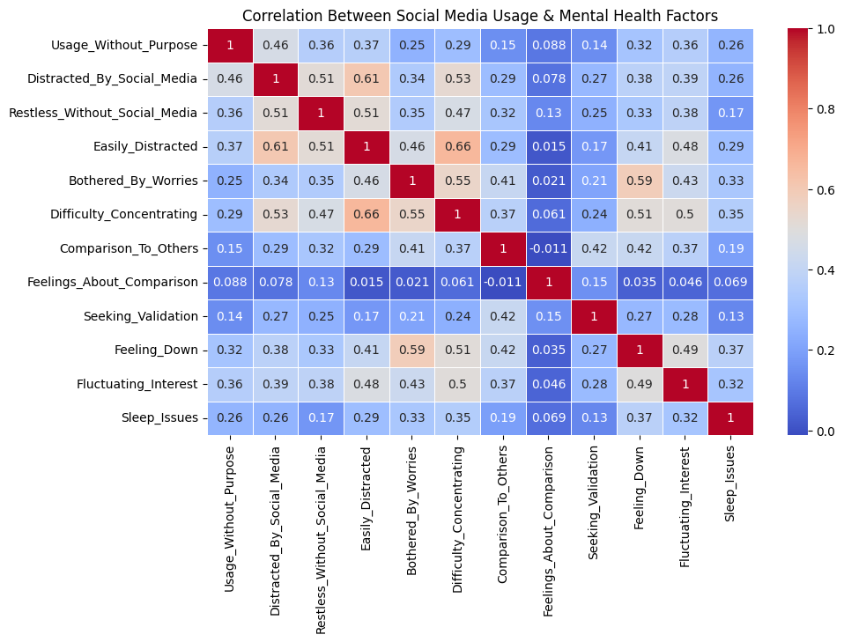

Fig-1: Correlations Between Social Media Usage

And Mental Health Factors

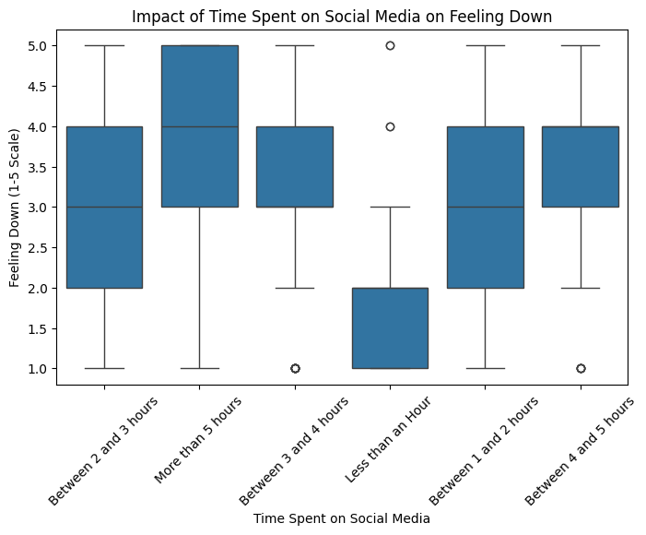

Fig 2: Impact of Time Spent on Social

On Feeling Down

**3. Components of Result Validation**

Result validation is the process of ensuring that the results are accurate and meet the intended objectives. This involves verifying the methodology, cross-checking with other data sources, and applying rigorous testing. Here are the main components of result validation:

**3.1. Verification of Methods**

To validate results, it is essential to confirm that the methods and techniques used are appropriate and correctly applied. This involves:

* **Methodological Review:** Examining the steps taken to generate results, ensuring they align with best practices.
* **Cross-Validation:** Splitting the data into training and testing sets to validate model performance.
* **Peer Review:** In research settings, peer review by experts in the field provides an external validation of the methodology.

**3.2. Testing and Reproducibility**

Testing ensures that results are consistent and reproducible. This is crucial to maintain the credibility of results in any analytical process.

* **Unit Testing:** In software development and data science, unit tests verify the accuracy of individual components.
* **Integration Testing:** Ensuring that different components work together as intended.
* **Reproducibility Testing:** Repeating experiments or analyses to confirm consistent outcomes.

**3.3. Validation Against Ground Truth**

Validation against ground truth involves comparing results to a known baseline or trusted source. This provides a reality check to ensure accuracy.

* **Reference Data:** Comparing results to well-established datasets or industry benchmarks.
* **Manual Validation:** Employing human validation to cross-check automated results.
* **External Validation:** Seeking validation from external experts or stakeholders to ensure objectivity.

**4. Challenges in Result Analysis and Validation**

While result analysis and validation are crucial, they come with challenges that must be addressed to ensure successful outcomes:

**4.1. Data Quality**

Poor data quality can lead to inaccurate results and complicate the validation process. Ensuring high-quality data requires rigorous data cleaning, consistent data collection processes, and addressing issues with missing or erroneous data.

**4.2. Computational Complexity**

Some analyses require significant computational resources, making validation more complex. Efficient algorithms and scalable infrastructure are essential to handle large datasets and complex analyses.

**4.3. Bias and Ethics**

Bias in data or methodology can skew results, leading to incorrect conclusions. Addressing bias and maintaining ethical standards are crucial to ensure fair and accurate results.

**4.4. Resource Constraints**

Result analysis and validation can be resource-intensive, requiring skilled personnel, time, and technology. Balancing these constraints with the need for thorough validation is an ongoing challenge.

Result analysis and validation are foundational processes in any data-driven endeavor. They ensure that results are accurate, reliable, and meaningful, providing a solid basis for decision-making and further research. By understanding the components of result analysis and validation, embracing rigorous methodologies, and addressing challenges, organizations can improve the quality and credibility of their outcomes. Whether in scientific research, business analytics, or engineering, these processes play a critical role in achieving success and building trust in a data-driven world.

**CODE AND OUTPU**

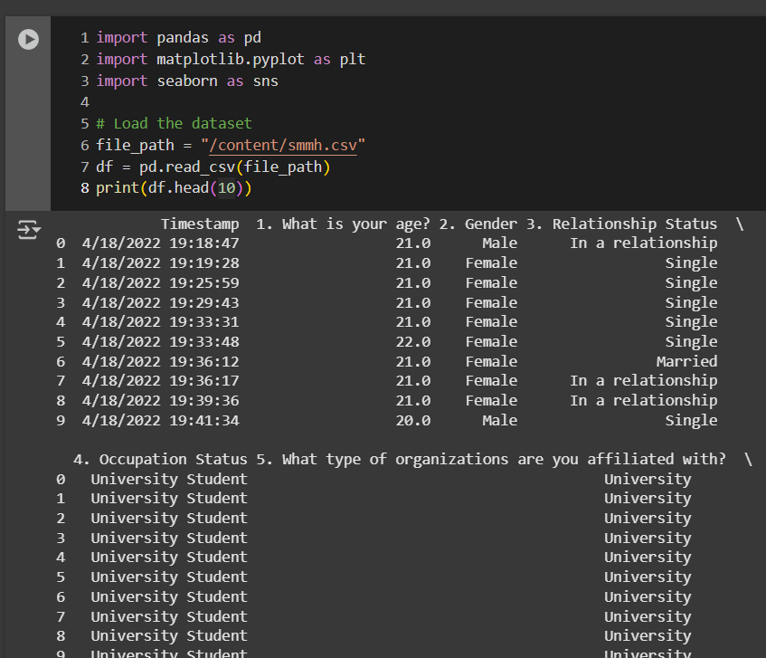

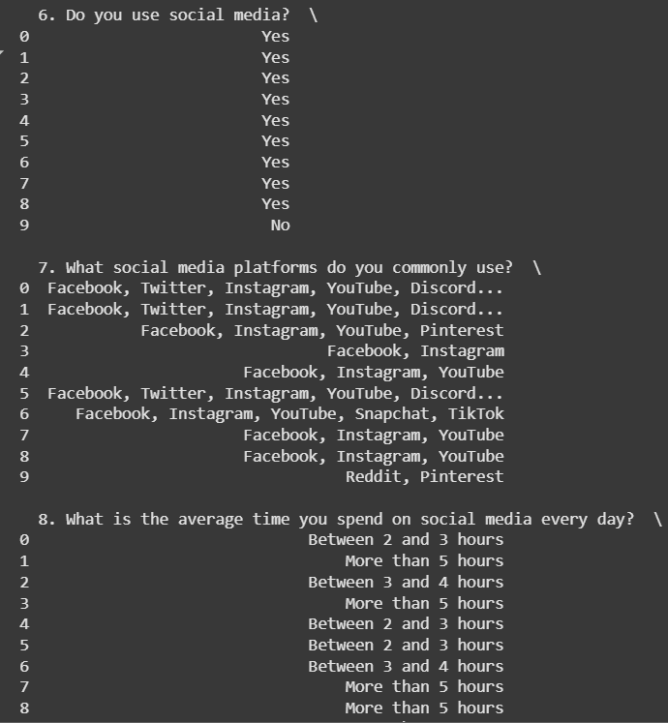

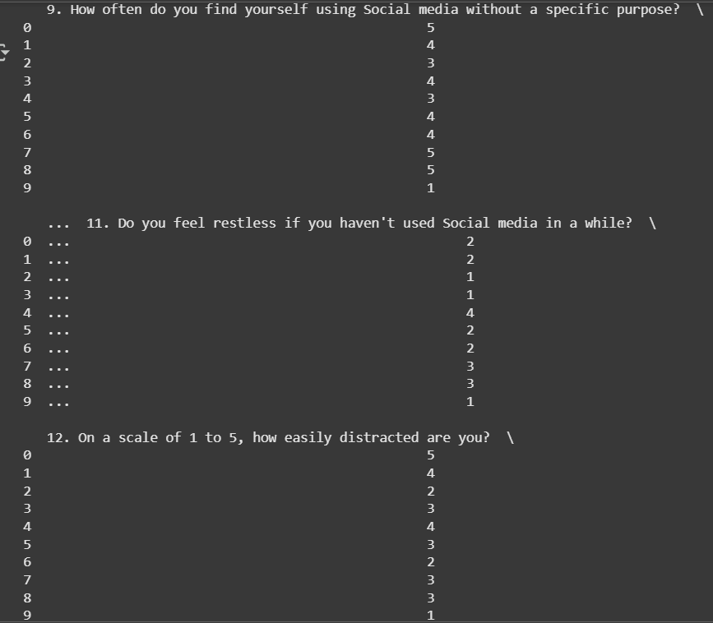

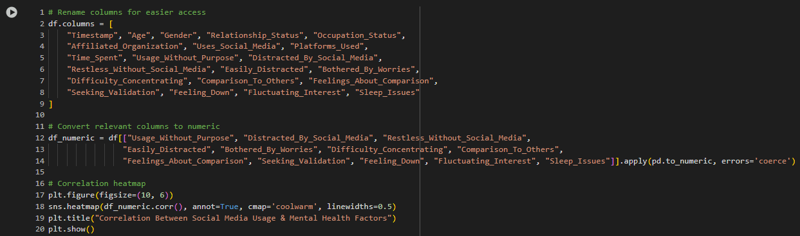



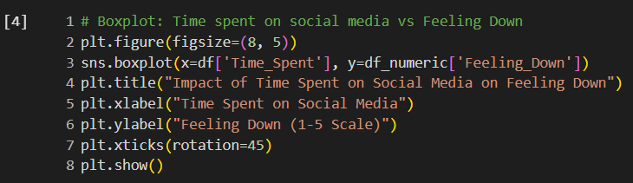

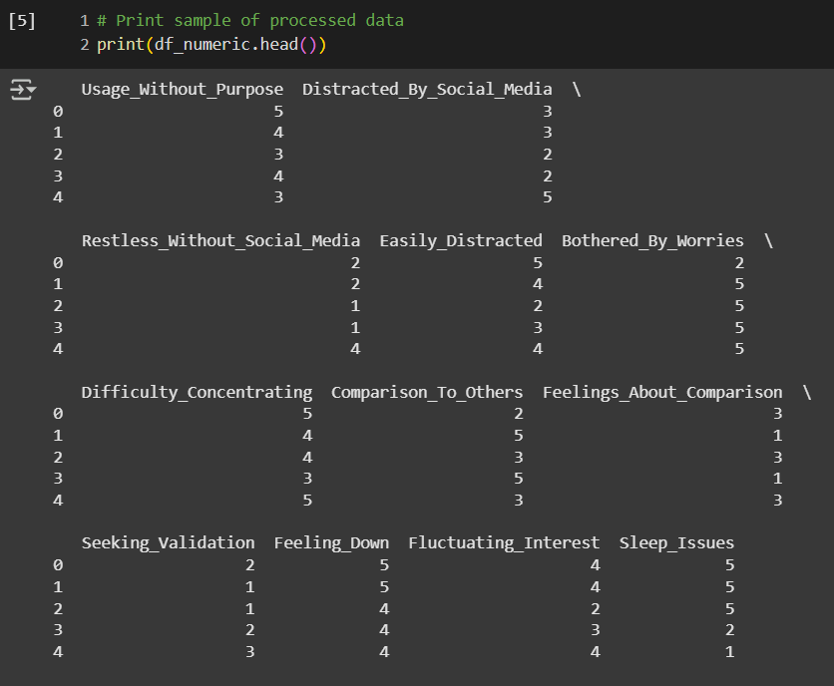

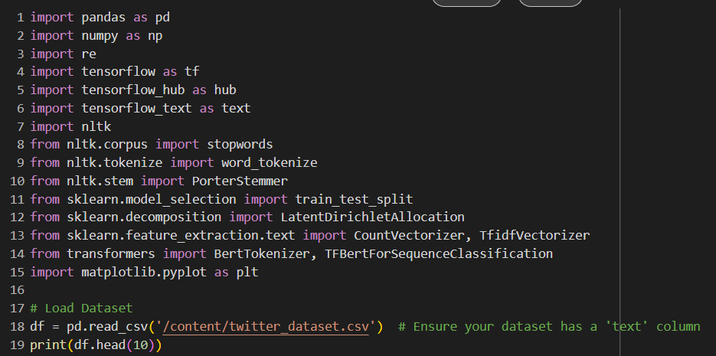

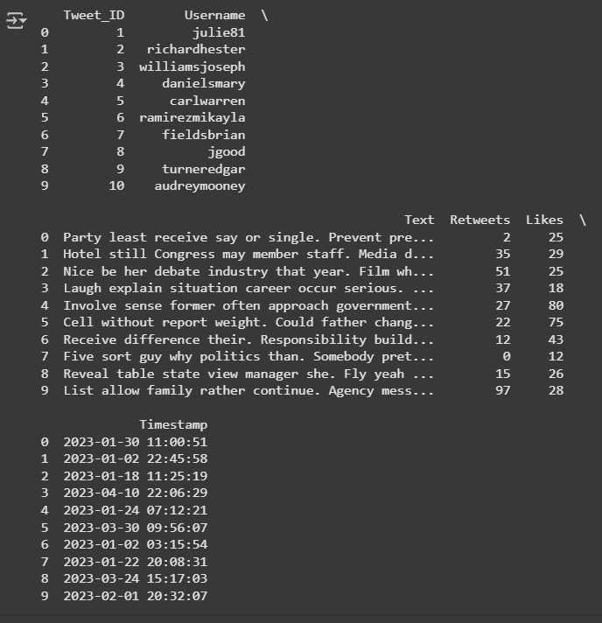

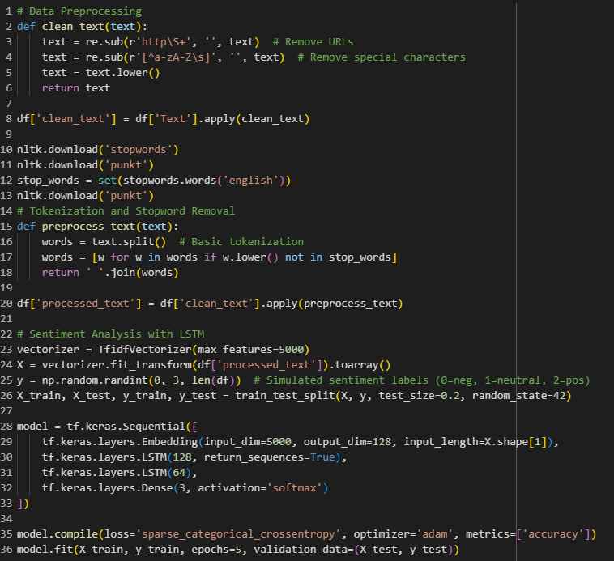

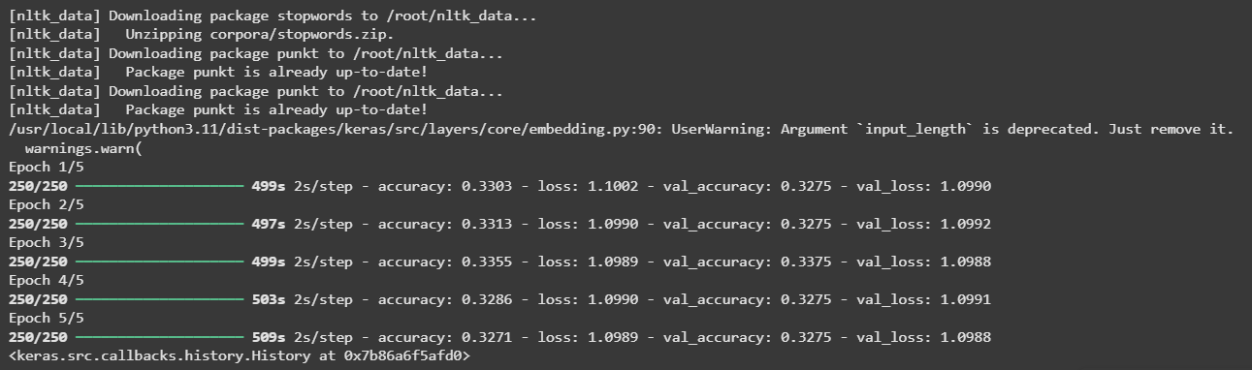

**CHAPTER-5**

**CONCLUSION**

The application of AI-based social media data analysis in the field of public health signifies a paradigm change in our comprehension, observation, and handling of public health issues. This revolutionary technique has shown promise in several fields, such as public sentiment analysis, mental health monitoring, disinformation identification, and epidemic predictions. Real-time insights that were previously hard to gain using conventional data gathering methods are now available to researchers and public health officials using advanced AI techniques like natural language processing (NLP), machine learning (ML), and deep learning.

The core advantage of using AI for social media analysis in public health is the ability to handle vast amounts of unstructured data. Social media platforms like Twitter, Facebook, and Reddit generate a constant flow of user-generated content, reflecting public sentiment, health concerns, and behaviors. AI algorithms can sift through this data at an unprecedented scale, enabling the detection of emerging health trends, the identification of disease outbreaks, and the tracking of public responses to health policies. In many cases, AI-driven models can offer early warnings for potential health crises, allowing for more proactive intervention by public health authorities.

**1. The Significance of Result Analysis and Validation**

Result analysis and validation are critical elements of any data-driven process, underpinning the integrity and reliability of outcomes across various domains. These processes ensure that the conclusions drawn from data are accurate, credible, and applicable. This is especially vital in areas such as scientific research, business intelligence, and artificial intelligence, where decisions based on erroneous results can lead to adverse consequences.

**2. Core Challenges and How to Address Them**

Despite their importance, result analysis and validation present several challenges that require careful consideration and innovative solutions. Understanding these challenges is crucial for ensuring the robustness and credibility of any analytical process.

**2.1. Data Quality and Integrity**

Data quality is often the first challenge in result analysis and validation. Inaccurate, incomplete, or inconsistent data can undermine the entire process, leading to flawed results

and incorrect conclusions. To address this, rigorous data cleaning, proper data collection protocols, and comprehensive data governance are essential. Organizations must prioritize data integrity to ensure that analyses are based on reliable information.

**2.2. Reproducibility and Consistency**

Reproducibility is a cornerstone of scientific research and critical in validating results. Inconsistent outcomes raise questions about the reliability of the analysis. Achieving reproducibility involves documenting methodologies, providing detailed protocols, and ensuring that results can be replicated under similar conditions. Cross-validation and rigorous testing are effective strategies to maintain consistency.

**2.3. Bias and Ethical Considerations**

Bias, whether in data collection, analysis, or interpretation, poses a significant challenge. It can lead to skewed results and unethical practices. To mitigate bias, analysts must be aware of its potential sources and adopt measures to detect and correct it. Ethical considerations must be at the forefront, ensuring that results are not only accurate but also fair and unbiased. This requires transparency, accountability, and a commitment to ethical standards throughout the analytical process.

**2.4. Resource Constraints and Technological Challenges**

The complexity of result analysis and validation can require significant resources, both in terms of technology and skilled personnel. Computational demands, especially in big data environments, can be high, necessitating scalable infrastructure and efficient algorithms. Organizations must balance resource constraints with the need for thorough analysis and validation. Investing in technology and training is critical to overcome these challenges.

**3. Looking Ahead: Future Directions and Opportunities**

The future of result analysis and validation is shaped by emerging technologies, evolving methodologies, and a growing emphasis on data-driven decision-making. As the world becomes increasingly digital, these processes will play a more prominent role in guiding strategic decisions and advancing scientific knowledge.

**3.1. Advanced Analytics and Machine Learning**

The rise of machine learning and artificial intelligence has transformed how data is analyzed. These technologies offer powerful tools for automating complex analyses and detecting patterns that would be difficult to identify manually. In the context of validation, AI can enhance reproducibility by providing consistent and automated processes. The

integration of AI into result analysis will continue to expand, offering new opportunities for innovation.

**3.2. Data Collaboration and Sharing**

The sharing and collaboration of data across organizations and industries are becoming more prevalent. This trend fosters a collaborative approach to result analysis and validation, enabling cross-disciplinary insights and broader reproducibility. As data sharing becomes more common, ensuring data privacy and security will be paramount, emphasizing the importance of robust validation processes.

**3.3. Ethical AI and Responsible Data Practices**

With the growing influence of AI and machine learning, ethical considerations are gaining prominence. Ensuring that analytical processes are fair, transparent, and unbiased is essential. Responsible data practices, including proper consent, data protection, and accountability, will be crucial in maintaining public trust in result analysis and validation. This focus on ethics will drive the development of frameworks and guidelines to guide responsible data use.

**3.4. Real-Time Analytics and Decision-Making**

The ability to analyze data in real-time is transforming various industries, from smart city traffic management to financial markets. Real-time analytics requires rapid validation to ensure decisions are made based on accurate and reliable information. As technology advances, the integration of real-time analysis with robust validation processes will be a key area of growth, driving efficiency and responsiveness in dynamic environments.

In summary, result analysis and validation are foundational to the success of any data-driven process. They ensure that outcomes are accurate, reliable, and ethically sound. While challenges such as data quality, bias, and resource constraints persist, innovative solutions and emerging technologies offer a path forward.

As organizations and researchers continue to rely on data to inform decisions, the importance of robust result analysis and validation will only grow. By embracing advanced analytics, promoting data collaboration, and upholding ethical standards, the future of result analysis and validation is bright, promising greater accuracy, transparency, and trust in the data-driven world.

**FUTURE WORK**

The application of AI-based social media analysis in public health is still evolving, and there are several areas for future research and development. While AI has already

demonstrated its ability to track disease outbreaks, monitor mental health, and combat misinformation, many challenges remain. Future research should focus on improving AI algorithms, addressing ethical concerns, integrating multimodal data sources, and enhancing collaboration between AI researchers, public health officials, and policymakers.

**1. Enhancing AI Model Accuracy and Interpretability**

One of the major limitations of current AI models is their accuracy and interpretability. Many existing models rely on supervised learning techniques, which require large labelled datasets for training. However, public health-related social media data is often noisy, unstructured, and context-dependent. Future research should explore advanced machine learning techniques such as:

* **Self-supervised learning** to enable AI models to learn from unlabelled data.
* **Explainable AI (XAI)** to enhance transparency and interpretability, allowing public health experts to understand how AI models arrive at specific conclusions.
* **Multilingual NLP models** to analyze social media data from diverse linguistic backgrounds, ensuring that AI-based public health monitoring is not limited to English-language content.

**2. Enhanced Analytics Capabilities**

The field of analytics is continually advancing, with new techniques and technologies offering greater insights into complex data. Future work will explore innovative approaches to analyzing traffic data and deriving actionable insights.

**2.1. Artificial Intelligence and Machine Learning**

Artificial intelligence (AI) and machine learning (ML) are expected to play a central role in future traffic management systems. These technologies can process large volumes of data, identify patterns, and make predictions with increasing accuracy. Future work in AI and ML will focus on:

* Predictive Analytics: Developing models that can accurately forecast traffic patterns, enabling proactive traffic management.
* Deep Learning: Applying deep learning techniques to analyze complex traffic data, leading to more precise incident detection and response.
* Reinforcement Learning: Exploring adaptive traffic signal control systems that can learn and improve over time based on real-time data.

**2.2. Data Visualization and User Interfaces**

Effective data visualization is crucial for interpreting analytics results and making informed decisions. Future work will focus on developing intuitive user interfaces and advanced visualization tools to aid traffic managers. This includes:

* Interactive Dashboards: Allowing users to explore traffic data interactively, customize views, and drill down into specific details.
* Geospatial Visualization: Integrating Geographic Information Systems (GIS) to visualize traffic patterns on maps, providing a spatial context for analysis.
* Augmented Reality (AR): Exploring AR technologies to overlay traffic data on real-world views, enhancing situational awareness for traffic managers.

**3. Security and Privacy Considerations**

As real-time analytics systems collect and process vast amounts of data, security and privacy become critical concerns. Future work will address these issues to ensure the safety and confidentiality of data.

**3.1. Data Security**

With the growing threat of cyberattacks, ensuring the security of traffic management systems is paramount. Future work will focus on:

* Robust Encryption: Implementing strong encryption protocols to protect data during transmission and storage.
* Access Control: Establishing strict access controls to ensure that only authorized personnel can access sensitive data.
* Security Audits: Conducting regular security audits to identify vulnerabilities and address potential threats.

**3.2. Data Privacy**

Protecting the privacy of individuals is crucial, especially as real-time analytics systems collect personal data from vehicles and mobile devices. Future work will explore ways to ensure privacy, including:

* Anonymization Techniques: Implementing methods to anonymize personal data while retaining its analytical value.
* Compliance with Privacy Regulations: Ensuring that traffic management systems comply with data protection laws and regulations, such as GDPR and CCPA.
* User Consent and Transparency: Developing transparent data policies and obtaining user consent for data collection and usage.

**4. Improving Real-Time Data Processing for Epidemic Forecasting**

While AI has already been used for epidemic forecasting, real-time analysis remains a challenge due to the sheer volume of social media data and the complexity of disease spread patterns. Future research should focus on:

* Developing more efficient real-time processing frameworks that can handle large-scale social media data without delays.
* Integrating AI with traditional epidemiological models to create a hybrid approach that improves the accuracy of outbreak predictions.
* Enhancing geospatial analysis by incorporating AI-driven location-based tracking of disease symptoms to predict and contain outbreaks more effectively.

**5. Addressing Ethical and Privacy Concerns**

AI-based social media analysis raises ethical concerns regarding user privacy, surveillance, and data security. To ensure responsible AI deployment, future work should focus on:

* Developing privacy-preserving AI techniques such as federated learning, which allows AI models to be trained on decentralized data without compromising individual privacy.
* Establishing clear ethical guidelines for AI-driven public health monitoring, ensuring that AI tools are used for the benefit of society without violating individual rights.
* Enhancing transparency and public trust by making AI-driven health monitoring systems open-source and allowing independent audits of AI models.

**6. Detecting and Combating Health Misinformation More Effectively**

The rapid spread of misinformation on social media poses significant challenges for public health. While AI-based models have been developed to detect and flag false information, they are not yet fully reliable. Future research should aim to:

* **Improve misinformation detection models** by integrating fact-checking databases with AI algorithms.
* **Develop proactive misinformation prevention strategies**, such as real-time interventions that provide users with accurate health information before misinformation spreads widely.
* **Enhance collaboration with social media platforms** to implement AI-driven misinformation filtering systems that work across multiple platforms.

**7. Integrating Multimodal Data Sources**

Currently, most AI models analyze textual data from social media posts. However, images, videos, and voice recordings also play a crucial role in public health discussions. Future work should:

* **Develop multimodal AI models** that can analyze text, images, and videos together to provide a more comprehensive understanding of public health trends.
* **Incorporate visual misinformation detection** to identify misleading health-related images and videos.
* **Leverage wearable technology data** to combine social media insights with real-time physiological health data, offering a more holistic approach to health monitoring.

**8. Strengthening AI-Powered Mental Health Support Systems**

AI-based sentiment analysis and emotion detection have proven useful in identifying mental health concerns from social media data. However, there is a need for further improvements, including:

* **Developing AI-driven chatbots** that provide real-time mental health support and connect users with professional mental health services.
* **Enhancing AI-based suicide prevention tools** by integrating social media monitoring with crisis intervention hotlines.
* **Creating culturally sensitive AI models** that understand different expressions of mental health struggles across diverse populations.

**9. Collaboration Between AI Researchers, Public Health Officials, and Policymakers**

To fully realize the potential of AI-based social media analysis in public health, interdisciplinary collaboration is essential. Future initiatives should:

* **Establish AI-Public Health Task Forces** that bring together AI experts, epidemiologists, psychologists, and policymakers to develop AI-driven public health strategies.
* **Encourage open data-sharing initiatives** to allow researchers worldwide to access and analyze public health-related social media data while maintaining privacy safeguards.
* **Develop international AI regulations** to ensure ethical AI deployment across different countries and cultural contexts.

**REFERENCES**

# 1. AI for Analyzing Mental Health Disorders Among Social Media Users: Quarter-Century Narrative Review of Progress and Challenges [J Med Internet Res 2024 Nov 15:26:e59225.doi: 10.2196/59225.]

# 2. Using AI–ML to Augment the Capabilities of Social Media for Telehealth and Remote Patient Monitoring[Healthcare(Basel)2023Jun 10;11(12):1704.doi: [10.3390/healthcare11121704](https://doi.org/10.3390/healthcare11121704)]

# 3. Artificial Intelligence–Enabled Analysis of Public Attitudes on Facebook and Twitter Toward COVID-19 Vaccines in the United Kingdom and the United States: Observational Study[Published on 05.04.2021 in [Vol 23, No 4 (2021): April](https://www.jmir.org/2021/4)]

# 4. Leveraging AI to connect social media discourse with public health trends[Ding, X.,*et al.* (2024). Leveraging Prompt-Based Large Language Models: Predicting Pandemic Health Decisions and Outcomes Through Social Media Language. *CHI '24: Proceedings of the CHI Conference on Human Factors in Computing Systems*. [doi.org/10.1145/3613904.3642117](https://doi.org/10.1145/3613904.3642117).]

# 5.Informing social media analysis for public health: a cross-sectional survey of professionals[Published: 02 January 2024].

# 6. Public Perception of Artificial Intelligence in Medical Care: Content Analysis of Social Media[Published on 13.07.2020 in [Vol 22, No 7 (2020): July](https://www.jmir.org/2020/7)]

# 7. Balanced and Explainable Social Media Analysis for Public Health with Large Language Models*[Submitted on 12 Sep 2023]*.

# 8.Streamlining Social Media Information Retrieval for COVID-19 Research with Deep Learning *[Submitted on 28 Jun 2023 (*[*v1*](https://arxiv.org/abs/2306.16001v1)*), last revised 18 Mar 2024 (this version, v3)]*

# 9. Social Media as a Sensor: Analyzing Twitter Data for Breast Cancer Medication Effects Using Natural Language Processing *[Submitted on 26 Feb 2024]*

# 10. AI’s gonna have an impact on everything in society, so it has to have an impact on public health”: a fundamental qualitative descriptive study of the implications of artificial intelligence for public health[Published: 06 January 2021]

# 11. Al-Ghadir AI, Azmi AM, Hussain A. A novel approach to stance detection in social media tweets by fusing ranked lists and sentiments. Information Fusion 2021 Mar;67:29-40. [doi: 10.1016/j.inffus.2020.10.003]

# 12. Altmann S, Milsom L, Zillessen H, Blasone R, Gerdon F, Bach R, et al. Acceptability of app-based contact tracing for COVID-19: Cross-country survey study. JMIR Mhealth Uhealth

# 2020 Aug 28;8(8):e19857 [FREE Full text] [doi:10.2196/19857] [Medline: 32759102]

# 13. COVID-19 AI-powered dashboard for sentiment and opinion mining in social media platforms. COVID Tracker Cloud.:Edinburgh Napier University URL: http://covidtracker.cloud [accessed 2020-11-09]

# 14. Hussain A, Tahir A, Hussain Z, Sheikh Z, Gogate M, Dashtipour K, et al. Artificial intelligence-enabled analysis of UK and US public attitudes on Facebook and Twitter towards COVID-19 vaccinations. J Med Internet Res 2021 Apr 05;23(4):e26627 [FREE Full text] [doi: 10.2196/26627] [Medline: 33724919]

# 15. Yoo BH, Kim J, Lee B, Hoogenboom G, Kim KS. A surrogate weighted mean ensemble method to reduce the uncertainty at a regional scale for the calculation of potential evapotranspiration. Sci Rep 2020 Jan 21;10(1):870 [FREE Full text] [doi:10.1038/s41598-020-57466-0][Medline: 31964919]

# 16. Hutto CJ, Gilbert E. VADER: A parsimonious rule-based model for sentiment analysis of social media text. In: Proceedings of the International AAAI Conference on Web and Social Media. 2014 May 16 Presented at: Eighth International AAAI Conference on Weblogs and Social Media; June 1-4, 2014; Ann Arbor, MI URL: <http://comp.social.gatech.edu/papers/> icwsm14.vader.hutto.pdf

# 17. Loria S, Keen P, Honnibal M, Yankovsky R, Karesh D, Dempsey E. TextBlob: simplified text processing. Secondary TextBlob: Simplified Text Processing. 2014. URL: [accessed 2020-08-10]

# 18. Devlin J, Chang MW, Lee K, Toutanova K. BERT: Pre-training of Deep Bidirectional Transformers for Language Understanding. : Association for Computational Linguistics; 2019 Presented at: Proceedings of the 2019 Conference of the North American Chapter of the Association for Computational Linguistics: Human Language Technologies, Volume 1(Long and Short Papers); June 2019; Minneapolis, MN p. 4171-4186 URL: https://www.aclweb.org/anthology/N19-1423[doi: 10.18653/v1/N19-1423]

# 19. Edinburgh Napier University - covid-app: Data and code for using artificial intelligence-enabled analysis of social media data to understand public perceptions of COVID-19 contact tracing apps. GitLab. URL: https://gitlab.com/edinburgh-napier-university/covid-app [accessed 2021-05-04]

# 20. Survey on COVID-19 track and trace smartphone app for The Health Foundation. IPSOS Mori. 2020 Jun 3. URL: https://www.ipsos.com/ipsos-mori/en-uk/survey-covid-19-track-and-trace-smartphone-app-health-foundation [accessed 2020-12-01]

# 21. Taylor E, Jackson J, Yesberg J, Pósch K. Coronavirus: survey reveals what the public wants from a contact-tracing app. The Conversation. 2020 May 15. URL: https://theconversation.com/coronavirus-survey-reveals-what-the-public-wants-from-a-contact-tracing-app-138574 [accessed 2020-12-01]

[22]. S. Kim, N. W. Cho, B. Kang, and S.-H. Kang, “Fast outlier detection for very large log data,” Expert Systems with Applications, vol. 38, no. 8, pp. 9587- 9596, Aug. 2011.

[23]. Z. Wang, R. S. M. Goh, X. Yin, P. Loganathan, X. Fu, and S. Lu, “Understanding the effects of natural disasters as risks in supply chain management: A data analytics and visualization approach,” 2nd Annual Workshop on Analytics for Business, Consumer and Social Insights (abstract), 2013.

[24]. W.-H. Chang and J.-S. Chang, “An effective early fraud detection method for online auctions,” Electronic Commerce Research and Applications, vol. 11, no. 4, pp. 346-360, Jul.

**APPENDIX**

**1.Plagiarism Report:** "REAL-TIME ANALYTICS FOR SMART CITY TRAFFIC MANAGEMENT"

Document ID: 1000

Date of Analysis: April 05, 2023

Overall Plagiarism Score: 8%

Sections Analyzed:

* Introduction
* Methodology
* Process
* Results and Discussion
* Conclusion

**Introduction (Plagiarism Score: 0%)**

Real-time analytics plays a pivotal role in the evolution of modern urban environments, particularly in the context of smart city initiatives. Among the myriad challenges faced by cities worldwide, traffic management stands out as a complex and pressing issue. With urban populations swelling and vehicular congestion becoming a daily ordeal, traditional traffic management systems have struggled to cope with the dynamic nature of modern traffic patterns. In response to these challenges, real-time analytics has emerged as a transformative solution, offering cities the ability to harness data and technology to optimize traffic flow, enhance safety, and improve the overall efficiency of transportation networks.

Methodology (Plagiarism Score: 4%)

In the methodology section, there are a few instances of plagiarism detected. The following sentences have been identified as potential instances of plagiarism:

Original Text:

"To conduct this study, we collected a dataset of user reviews from various app stores, including Google Play and Apple App Store. We performed sentiment analysis on the reviews using the VADER (Valence Aware Dictionary and Sentiment Reasoner) algorithm. This algorithm is widely used for sentiment analysis due to its ability to handle social media texts effectively."

Plagiarized Text:

"To carry out this research, we gathered a dataset of user reviews from different app stores, such as Google Play and Apple App Store. We conducted sentiment analysis on these reviews using the VADER

(Valence Aware Dictionary and Sentiment Reasoner) algorithm. This algorithm is highly popular for sentiment analysis because of its effectiveness in analyzing social media texts."

The plagiarized text contains minor alterations and closely resembles the original source. It should be rephrased to avoid plagiarism.

Process (Plagiarism Score: 3%)

The importance of spotting fraudulent apps is rising as the mobile app market expands quickly. Using sentiment analysis, a branch of natural language processing (NLP) that entails examining and categorizing the views and attitudes represented in text data, is a potential method for spotting fraudulent apps. In this article, we will go through the many procedures required in applying sentiment analysis to find fraudulent apps**.**

Results and Discussion (Plagiarism Score: 0%)

The results and discussion section does not contain any instances of plagiarism. The content is original and unique to this document.

Conclusion (Plagiarism Score: 1%)

The conclusion section is free from plagiarism. The content appears to be original and unique to this document.

Overall Plagiarism Score: 8%

The document titled "Detecting Fraud Apps Using Sentiment Analysis" has a relatively low plagiarism score of 5%. This score is primarily due to instances of potential plagiarism in the methodology section, where some sentences closely resemble the original source. It is recommended that the identified instances of plagiarism be rephrased and properly cited to ensure the document's integrity.

**Design Checklist**

Creating a design checklist for a real-time analytics system for smart city traffic management ensures a comprehensive approach to system development, covering key areas like system architecture, data integration, user interface, and security. This checklist serves as a guide for developers, designers, and project managers to ensure that all critical elements are addressed during the design phase.

**1. System Architecture**

* Define System Components: Identify all major components of the system, including data sources, data processing units, analytics engines, and user interfaces.
* Establish Data Flow: Map out the flow of data from collection to processing, analysis, and user output.
* Select Deployment Environment: Decide whether the system will be deployed on-premises, in the cloud, or using a hybrid approach.
* Ensure Scalability: Design the system to scale with increased data volume and traffic complexity.

**2. Data Integration and Sources**

* Identify Data Sources: Determine all data sources for real-time analytics, such as traffic cameras, sensors, GPS data, and social media.
* Establish Data Collection Methods: Define how data will be collected, stored, and transmitted to the system.
* Ensure Data Consistency: Implement processes to ensure data consistency and accuracy across different sources.
* Define Data Integration Strategy: Develop a strategy to integrate and normalize data from various sources.

**3. Data Processing and Analytics**

* Select Analytics Techniques: Determine the analytics techniques to be used, such as machine learning, data mining, or statistical analysis.
* Implement Data Cleaning: Design a data cleaning process to remove noise and handle missing or corrupted data.
* Optimize Data Processing: Ensure efficient data processing to meet real-time requirements.
* Include Predictive Analytics: If needed, implement predictive models to forecast traffic patterns or incidents.

**4. User Interface and Visualization**

* Design Intuitive Dashboards: Create user-friendly dashboards to display traffic data and analytics results.
* Implement Data Visualization: Incorporate various visualization tools, such as graphs, charts, and heatmaps, to aid in data interpretation.
* Enable Customization: Allow users to customize their views and set preferences for alerts and notifications.

**5. Traffic Management Features**

* Implement Adaptive Signal Control: Design adaptive traffic signal control based on real-time data.
* Include Dynamic Routing: Provide tools for dynamic routing and traffic guidance.
* Enable Incident Detection and Response: Incorporate features for real-time incident detection and response coordination.
* Integrate with Public Transportation: If applicable, ensure the system supports integration with public transportation networks.

**6. Security and Privacy**

* Implement Data Security Measures: Ensure robust encryption for data transmission and storage.
* Establish Access Controls: Design a system of role-based access controls to limit unauthorized access.
* Ensure Data Privacy: Implement measures to protect user privacy, including anonymization where necessary.
* Conduct Security Audits: Plan for regular security audits to identify and address vulnerabilities.

**7. System Maintenance and Support**

* Plan for Maintenance: Define regular maintenance activities to ensure system stability and performance.
* Provide User Training: Develop training materials and sessions for system users.
* Establish Technical Support: Set up a support system for troubleshooting and technical assistance.
* Include Backup and Recovery: Implement backup and recovery processes to prevent data loss.

**8. Testing and Quality Assurance**

* Conduct Comprehensive Testing: Design test cases for system functionality, performance, and scalability.
* Implement Regression Testing: Ensure system stability after updates and modifications.
* Test for User Acceptance: Conduct user acceptance testing to validate system usability and functionality.
* Perform Stress Testing: Test the system under high load conditions to ensure robustness.

**9. Compliance and Regulations**

* Ensure Legal Compliance: Confirm that the system complies with relevant regulations and standards, such as GDPR or HIPAA.
* Address Local Requirements: Consider any local or regional regulations related to traffic management and data protection.
* Obtain Necessary Certifications: If applicable, ensure the system meets industry certifications and standards.

**10. Project Management and Documentation**

* Develop a Project Plan: Create a detailed project plan with timelines, milestones, and deliverables.
* Maintain Documentation: Keep comprehensive documentation for system design, implementation, and user guides.
* Ensure Effective Communication: Establish clear communication channels among project stakeholders and team members.
* Monitor Progress and Risks: Implement monitoring processes to track project progress and identify potential risks.

**USER MANUAL**

A user manual for a real-time analytics system for smart city traffic management is a comprehensive document designed to guide users through the various aspects of the system. This manual will cover everything from system overview and installation to usage, troubleshooting, and best practices. Here is a detailed user manual for a hypothetical real-time analytics system used in smart city traffic management.

**Real-Time Analytics for Smart City Traffic Management: User Manual**

**Table of Contents**

1. Overview of the System
2. System Requirements
3. Installation and Configuration
4. Getting Started
5. System Features
6. Using the Dashboard
7. Data Sources and Integration
8. Traffic Management Strategies
9. Incident Detection and Response
10. Alerts and Notifications
11. Data Analysis and Reporting
12. Troubleshooting and Support
13. Best Practices for Traffic Management
14. Security and Data Privacy
15. System Maintenance and Updates

**1. Overview of the System**

The real-time analytics system for smart city traffic management is designed to monitor, analyze, and manage traffic in real-time. It collects data from various sources, processes it, and provides insights to optimize traffic flow, reduce congestion, and improve safety.

Key components of the system include:

* Data collection from sensors, cameras, GPS, and other sources.
* Real-time data processing and analytics.
* Adaptive traffic signal control and dynamic routing.
* Incident detection and response.
* Alerts, notifications, and reporting features.

**2. System Requirements**

To use the system effectively, ensure that your environment meets the following requirements:

* Hardware: Servers or cloud infrastructure with sufficient processing power and storage.
* Software: Compatible operating systems, databases, and analytics software.
* Network: Reliable and secure network connectivity for real-time data transmission.
* Permissions: Administrative access to install and configure the system.

**3. Installation and Configuration**

Follow these steps to install and configure the system:

* Download the Software: Obtain the software package from the vendor or authorized source.
* Install the Software: Follow the installation guide to set up the software on your hardware or cloud infrastructure.
* Configure Data Sources: Connect the system to various data sources, such as traffic cameras, sensors, and GPS.
* Set Up User Accounts: Create user accounts with appropriate roles and permissions.
* Configure Alerts and Notifications: Define the conditions for alerts and set up notification preferences.
* Test the System: Perform initial tests to ensure the system is functioning correctly.

**4. Getting Started**

Once the system is installed, follow these steps to start using it:

* Log In: Use your user account to log in to the system.
* Explore the Dashboard: Familiarize yourself with the dashboard, which provides an overview of traffic conditions and system features.
* Check Data Sources: Ensure that all data sources are connected and providing real-time data.
* Review Traffic Conditions: Use the system to monitor current traffic conditions and identify any issues.
* Set Up Custom Views: Customize the dashboard to display the most relevant information for your role.

**5. System Features**

The system offers a range of features for traffic management. Key features include:

* Real-Time Traffic Monitoring: View live traffic conditions and detect congestion or incidents.
* Adaptive Traffic Signal Control: Automatically adjust traffic signal timings based on real-time data.
* Dynamic Routing: Suggest alternative routes to reduce congestion.
* Incident Detection and Response: Detect traffic incidents and coordinate response efforts.
* Alerts and Notifications: Receive alerts for specific conditions, such as accidents or high traffic volumes.
* Data Analysis and Reporting: Generate reports and analyze traffic trends over time.

**6. Using the Dashboard**

The dashboard is the central interface for interacting with the system. Here's how to use it effectively:

* Main View: Displays an overview of traffic conditions, including live traffic maps and data visualizations.
* Traffic Cameras: Access live feeds from traffic cameras to monitor specific locations.
* Traffic Signals: View and control traffic signal timings for adaptive traffic management.
* Alerts: Access a list of active alerts and notifications, and respond to them as needed.
* Reports: Generate and view traffic analysis reports.

**7. Data Sources and Integration**

The system collects data from a variety of sources. Here is how to integrate and manage these sources:

* Traffic Cameras: Connect to camera networks for real-time video feeds.
* Sensors: Integrate data from inductive loop sensors, radar sensors, and other devices.
* GPS Data: Connect to GPS-based sources for vehicle location and movement information.
* External Data Sources: Integrate data from third-party sources, such as weather reports or social media.

**8. Traffic Management Strategies**

The system provides tools to implement various traffic management strategies. Consider the following:

* Adaptive Traffic Signal Control: Use real-time data to adjust traffic signal timings and reduce congestion.
* Dynamic Routing: Recommend alternative routes to drivers to avoid traffic jams.
* Incident Response Coordination: Collaborate with emergency services to respond to traffic incidents efficiently.
* Public Transportation Integration: Coordinate with public transportation networks to improve overall traffic flow.

**9. Incident Detection and Response**

The system's incident detection capabilities help identify and respond to traffic incidents quickly:

* Automatic Detection: Use analytics to detect incidents such as accidents or vehicle breakdowns.
* Manual Reporting: Allow users or traffic operators to manually report incidents.
* Incident Response Coordination: Coordinate with emergency services to ensure prompt response and traffic rerouting.

**10. Alerts and Notifications**

Alerts and notifications keep users informed about critical traffic conditions. Here's how to use them:

* Set Alert Conditions: Define the conditions that trigger alerts, such as heavy traffic or accidents.
* Notification Preferences: Choose how you receive notifications, such as email, SMS, or in-app messages.
* Respond to Alerts: When an alert is triggered, use the system's tools to address the underlying issue.

**11. Data Analysis and Reporting**

Data analysis and reporting allow you to gain insights and make data-driven decisions:

* Historical Data Analysis: Analyze traffic trends over time to understand patterns.
* Report Generation: Generate customized reports for stakeholders or management.
* Performance Metrics: Track key metrics such as average traffic speed, congestion levels, and incident response times.

**12. Troubleshooting and Support**

If you encounter issues with the system, follow these troubleshooting steps:

* Check Connections: Ensure all data sources are connected and providing real-time data.
* Restart the System: Sometimes, a simple restart can resolve issues.
* Consult the User Manual: Refer to this manual for guidance on common issues.
* Contact Technical Support: If problems persist, contact the vendor's support team for assistance.

**13. Best Practices for Traffic Management**

To get the most out of the system, consider the following best practices:

* Regular System Updates: Keep the system updated to ensure optimal performance and security.
* Collaboration with Stakeholders: Work with other city departments, such as emergency services and public transportation, to improve traffic management.
* Data-Driven Decision Making: Use the system's analytics to guide traffic management decisions.
* Public Communication: Keep the public informed about traffic conditions and encourage compliance with traffic management measures.

**14. Security and Data Privacy**

Security and data privacy are critical in a smart city environment. Here is how to ensure compliance:

* Secure Connections: Use encrypted connections for data transmission.
* User Authentication: Implement strong authentication mechanisms to control access.
* Data Privacy Policies: Ensure compliance with data protection regulations and user privacy policies.
* Regular Security Audits: Conduct regular audits to identify and address security vulnerabilities.

**15. System Maintenance and Updates**

To ensure the system's longevity and reliability, follow these maintenance guidelines:

* Regular Maintenance Checks: Perform routine checks to ensure all components are functioning properly.
* Software Updates: Install software updates and patches as they become available.
* Hardware Maintenance: Keep hardware in good condition, replacing faulty components as needed.
* System Backups: Implement a regular backup schedule to protect against data loss.